Javier Jesús Macossay-Hernández EE 348L

March 31, 2016

**Prelab #8**

Exercise 1

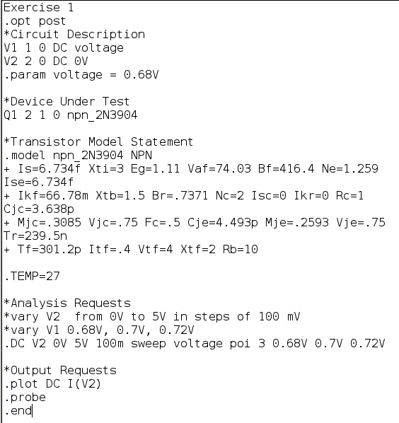

Netlist

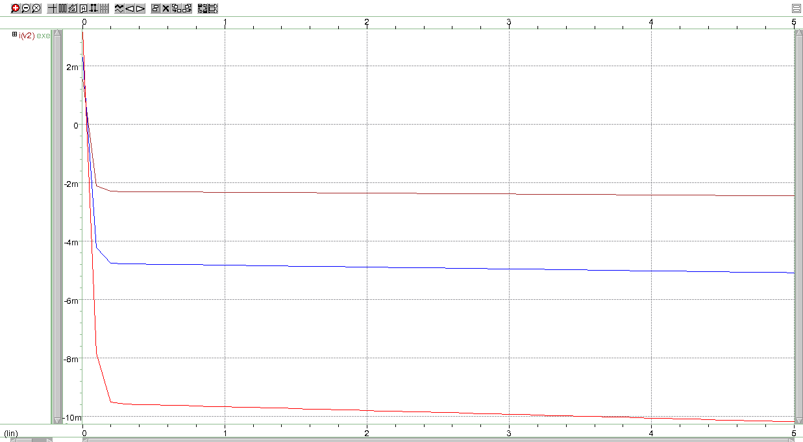

IC vs. V2

Exercise 4

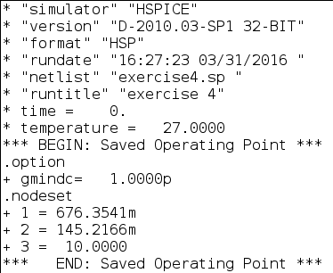

Starting Output

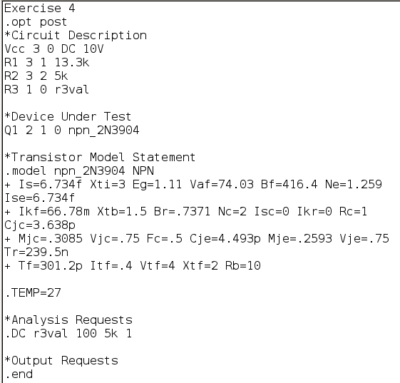

DC Sweep on R3 from 100Ω to 5kΩ

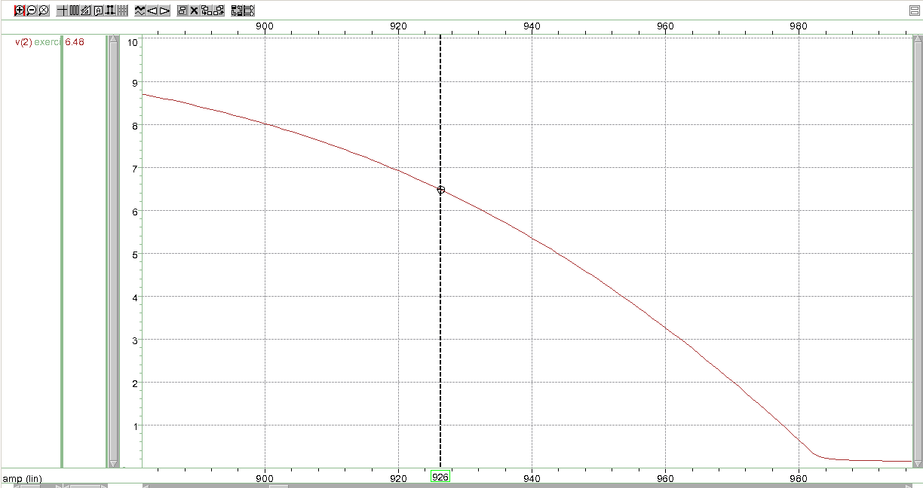

Value of R3 (923 Ω) where Vc is equal to 6.5V

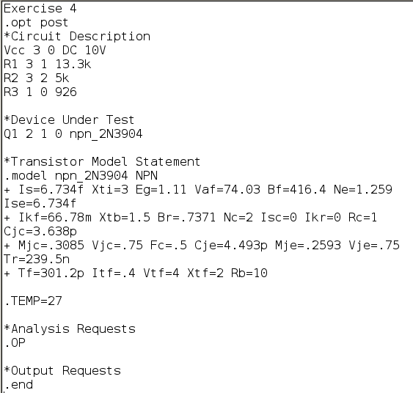

Final Netlist with modified R3 value

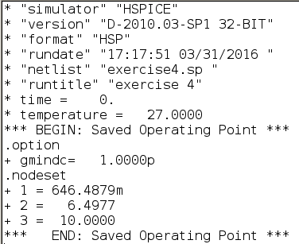

Output file with Vc is equal to 6.5V

Exercise 5

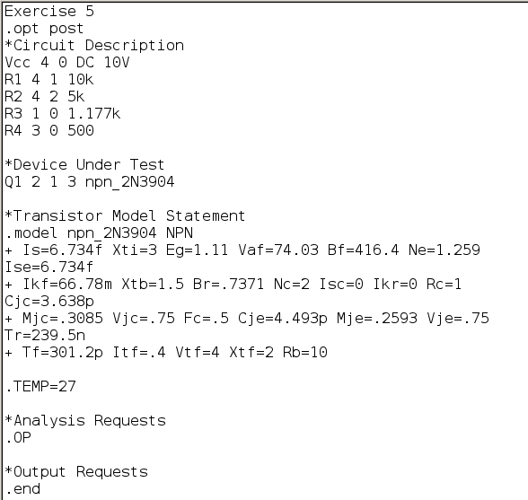

Starting Netlist

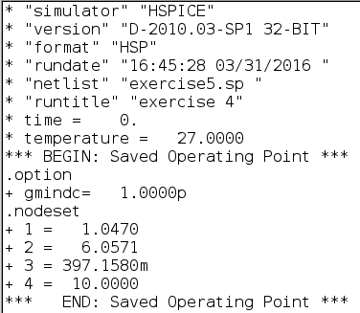

Starting Output

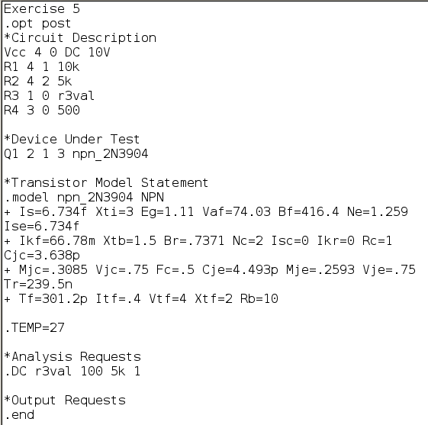

DC Sweep on R3 from 100Ω to 5kΩ

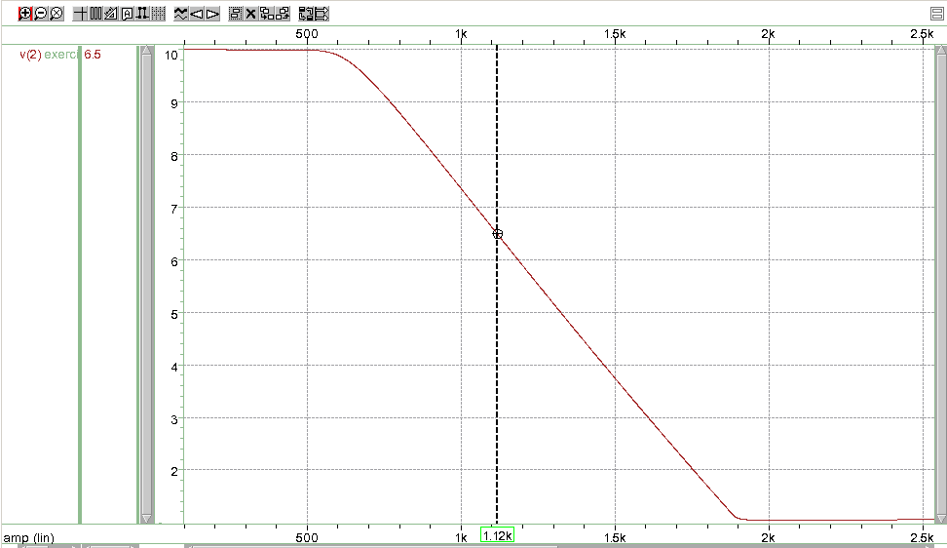

Value of R3 (1.12 kΩ) where Vc is equal to 6.5V

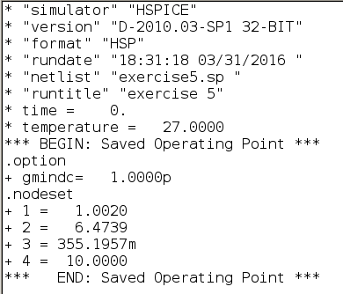

Output file with Vc is equal to 6.5V